Job Portal Management System
School of Computing
Bachelor of Technology in
Computer Science & Engineering By
P.NIVETHITHA (VTU24312)
10211CS224
Full Stack Application Development Slot : E2-B8


DEPARTMENT OF COMPUTER SCIENCE AND ENGINEERING SCHOOL OF COMPUTING

VEL TECH RANGARAJAN Dr.SAGUNTHALA R&D INSTITUTE OF SCIENCE AND TECHNOLOGY
(Deemed to be University Estd u/s 3 of UGC Act, 1956) CHENNAI 600 062, TAMILNADU, INDIA
April, 2026

BONAFIDE CERTIFICATE
It is certified that the work contained in the Full Stack Application De-velopment report titled “Job Portal Management System” by P.Nivethitha (VTU24312) has been carried out in Winter semester of Academic year 2025-2026 (WS2526).

Signature of Faculty Dr.N.V.S.Natteshan,
Assistant Professor(Senior Grade) Computer Science & Engineering
School of Computing Vel Tech Rangarajan Dr.Sagunthala R&D Institute of Science and Technology
April, 2026

Signature of Head of the Department
Dr. M.Kavitha Professor & Head
Computer Science & Engineering
School of Computing Vel Tech Rangarajan Dr.Sagunthala R&D Institute of Science and Technology
April, 2026

DECLARATION
I declare that this written submission represents my ideas in my own words and where others’ ideas or words have been included, I have adequately cited and referenced the original sources. I also declare that I have adhered to all principles of academic honesty and integrity and have not misrepresented or fabricated or falsified any idea/data/fact/source in my submission. I understand that any violation of the above will be cause for disciplinary action by the In-stitute and can also evoke penal action from the sources which have thus not been properly cited or from whom proper permission has not been taken when needed.

P.NIVETHITHA
Date: 06/05/2026

ABSTRACT
JobSpark is a full-stack Job Portal Management System developed using Spring Boot, Spring Security, Spring Data JPA, Thymeleaf, and MySQL. The system bridges the gap between job seekers and employers by providing a uni-fied platform for job discovery, application management, and candidate evalua-tion. The application supports three distinct user roles — Student (Job Seeker), Employer, and Admin — each with a dedicated dashboard and role-based ac-cess control enforced through Spring Security.
Students can register, build profiles, upload resumes, search and filter job listings, apply with cover letters, track application statuses in real time, book-mark jobs, and withdraw pending applications. Employers can post, edit, and delete job listings with expiry dates, view all applicants, read cover letters, and shortlist or reject candidates — with automated email notifications sent to stu-dents upon status changes. The Admin dashboard provides a complete platform overview including user distribution charts, application statistics, and full user management.
The frontend is built with HTML5, CSS3, Thymeleaf, and JavaScript ES6, featuring a glassmorphism UI design, animated particle backgrounds, Chart.js analytics dashboards, 3D card effects, and a fully responsive layout. All data is persistently stored in a MySQL relational database with Hibernate-managed entity relationships. The application runs on embedded Apache Tomcat at and requires no paid hosting or cloud infrastructure.

Keywords: Spring Boot, Spring Security, Spring Data JPA, Thymeleaf, MySQL, Hibernate, Role-Based Access Control, BCrypt, Chart.js, Full Stack Develop-ment

LIST OF FIGURES
  - Framework of the JobSpark Application 3
  - Data Flow Diagram of JobSpark Application 8
  - JobSpark Homepage with Particle Animation Hero Section 14
  - Login Page with Split-Screen Glassmorphism Design 15
  - Admin Dashboard with Platform Overview and Chart.js Analytics 16
  - Student Dashboard with Application Statistics and Charts 17
  - Employer Dashboard with Job Management Table and Analytics 18

LIST OF TABLES

  - Comparison of Job Portal Platforms 5

  - Database Tables and Key Columns 9
  - System Performance and Feature Analysis 19
  - Mapping of Project to Complex Engineering Problem (CEP) 28
  - Mapping of Project to Complex Engineering Activities (CEA) . 29
  - SDG Mapping for the Project 30

LIST OF ACRONYMS AND ABBREVIATIONS

API | Application Programming Interface
BCrypt | Blowfish Crypt Password Hashing Algorithm
CRUD | Create, Read, Update, Delete
CSS | Cascading Style Sheets
CSRF | Cross-Site Request Forgery
HTML | HyperText Markup Language
HTTP | HyperText Transfer Protocol
IDE | Integrated Development Environment
JPA | Java Persistence API
JPQL | Java Persistence Query Language
JS | JavaScript
MVC | Model View Controller
MySQL | My Structured Query Language
ORM | Object Relational Mapping
REST | Representational State Transfer
SMTP | Simple Mail Transfer Protocol

SQL Structured Query Language
UI User Interface
URL Uniform Resource Locator
UX User Experience

TABLE OF CONTENTS

Page.No

ABSTRACT iii
LIST OF FIGURES iv
LIST OF TABLES v
LIST OF ACRONYMS AND ABBREVIATIONS vi
- INTRODUCTION 1
  - Introduction 1
  - Aim of the Project 1
  - Scope of the Project 2
  - Framework 2
- SURVEY OF SIMILAR APPLICATION IN MARKET 4
- FRAMEWORK DESCRIPTION 6
  - Frontend Implementation 6
  - Backend Implementation 7
  - Database Implementation 8
- METHODOLOGIES 10
  - Project Architecture 10
  - DataFlow Diagram 10
  - Module 1: User Interface Module 11
  - Module 2: API and Backend Module 11
  - Module 3: Database Module 12
- RESULTS AND DISCUSSIONS 13
- CONCLUSION AND FUTURE ENHANCEMENTS 20
  - Conclusion 20
  - Future Enhancements 20
- SOURCE CODE 22
  - Source Code 22
- ADDRESSING COMPLEX ENGINEERING PROBLEM AND SDG 27
  - Mapping of the Project to Complex Engineering Problem (CEP) 27
  - Mapping of the Project to Complex Engineering Activities (CEA) 29
  - SDG Mapping 30
References 30

Chapter 1 INTRODUCTION

Introduction

Managing job applications and recruitment through manual methods is often inefficient and prone to errors. To address this, a full-stack web application named JobSpark is developed to provide a simple and organised platform for job discovery, application management, and candidate evaluation. The system enables students (job seekers) to view job listings, register, apply with cover letters, and track their application status in real time, while helping employers post jobs, manage applicants, and shortlist candidates efficiently. By leveraging Spring Boot, Spring Security, Spring Data JPA, Thymeleaf, and MySQL, the application ensures a secure, responsive, and user-friendly experience, making the overall recruitment process faster, more reliable, and more transparent.

Aim of the Project

The aim of this project is to design and develop a full-stack Job Portal Man-agement System that efficiently connects job seekers and employers through a secure, role-based web platform. The system focuses on simplifying the pro-cess of job discovery, application management, and candidate evaluation by providing a user-friendly interface, ensuring accurate data handling, and reduc-ing manual effort for both students and employers. It also aims to provide au-tomated email notifications, analytics dashboards, and complete administrative

oversight through a dedicated admin panel.

Scope of the Project

The scope of JobSpark encompasses the following functional areas. Stu-dents can register, login, upload resumes, apply for jobs with cover letters, track real-time application status (Pending, Shortlisted, Rejected), withdraw pend-ing applications, and bookmark interesting jobs. Employers can register, post and manage job listings with expiry dates, view all applicants, read cover let-ters through a modal popup, and shortlist or reject candidates with automated email notifications. The Admin panel provides a complete platform overview with analytics charts, application management, and user deletion capabilities. Future enhancements may include REST API integration, JWT authentication, AI-based job recommendations, cloud deployment, and a dedicated mobile ap-plication.

Framework

The proposed Job Portal Management System is developed using the Spring Boot framework — a powerful Java-based framework for building production-ready web applications. Spring Boot provides an embedded Apache Tom-cat server, auto-configuration, and starter dependencies that reduce boilerplate code. It utilises a component-based MVC architecture with distinct Controller, Service, and Repository layers, allowing the application to be divided into reusable and maintainable modules such as user management, job management, and ap-plication processing. Spring Security handles role-based authentication and BCrypt password encryption. Thymeleaf serves as the server-side template en-gine rendering dynamic HTML pages. MySQL with Spring Data JPA manages all data storage through Hibernate ORM. Chart.js provides real-time analyt-ics on dashboards, making it suitable for handling job listings, user profiles, application tracking, and email notifications.

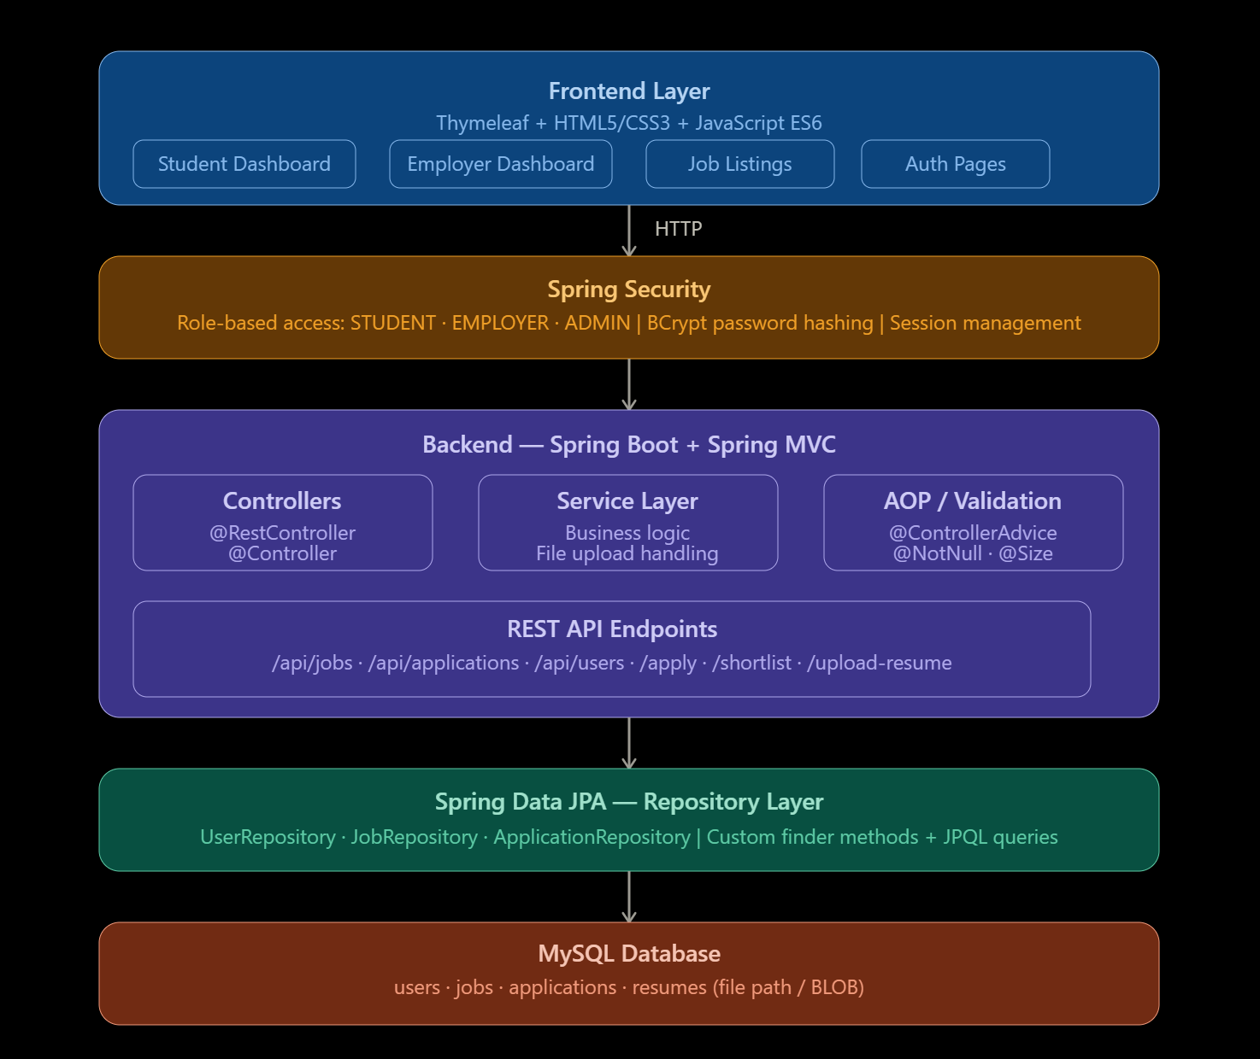

1777655108752_image.png
Figure 1.1: Framework of the JobSpark Application

Chapter 2

SURVEY OF SIMILAR APPLICATION IN MARKET

In the current market, several online job portal platforms have been devel-oped to simplify job discovery and recruitment processes. One of the most prominent platforms is LinkedIn (https://www.linkedin.com), which provides professional networking along with job listings, AI-based recommen-dations, recruiter tools, and skill endorsements. However, many premium fea-tures require paid subscriptions and the platform can be overwhelming for fresh graduates.
Similarly, Naukri.com (https://www.naukri.com) is India’s leading job portal targeting experienced professionals and freshers. It offers resume building, job alerts, and employer dashboards but lacks real-time application status tracking visible to candidates, and its interface contains many advertise-ments.
Global platforms like Indeed (https://www.indeed.com) aggregate job listings from multiple sources. While their search capability is strong, they do not provide employers with built-in applicant management tools or analyt-ics dashboards. Internshala (https://www.internshala.com) caters specifically to students but is limited to internships and does not support full-time job lifecycle management. Freshersworld provides job listings for fresh-ers but lacks an integrated employer dashboard and cover letter management.

This survey highlights that while current applications are functional, there is scope for a simplified, cost-effective, and feature-complete solution. The pro-posed Spring Boot-based JobSpark application addresses these needs by com-bining all required features at no cost with real-time tracking and a complete admin panel.
Table 2.1: Comparison of Job Portal Platforms
Feature | LinkedIn | Naukri | Indeed | Internshala | JobSpark
Role-Based Access | Yes | Partial | No | Partial | Yes
Real-Time Tracking | No | No | No | Partial | Yes
Email Notification | Yes | Yes | No | Yes | Yes
Analytics Dashboard | Yes | No | No | No | Yes
Resume Upload | Yes | Yes | Yes | Yes | Yes
Job Expiry Date | Yes | Yes | Yes | No | Yes
Cover Letter View | No | No | No | No | Yes
Application Withdraw | No | No | No | No | Yes
Job Bookmarks | Yes | Yes | Yes | Yes | Yes
Admin Control Panel | No | No | No | No | Yes
Free to Use | Partial | Partial | Yes | Yes | Yes

Chapter 3 FRAMEWORK DESCRIPTION

Frontend Implementation

    - Environment Setup

The development environment is set up using Eclipse IDE for Enterprise Java Developers with the Spring Tools 4 plugin. The frontend is built using HTML5, CSS3, JavaScript ES6, and Thymeleaf as the server-side template engine. Ex-ternal libraries loaded via CDN include Chart.js for dashboard analytics and the Inter font from Google Fonts. The application is tested using Google Chrome at http://localhost:8080.
    - Structure of the Project

The frontend follows a modular Thymeleaf template structure organised into subdirectories: templates/auth/ for login and register pages, for stu-dent dashboard, applications, profile, saved jobs, and change password pages, templates/employer/ for employer dashboard, post-job, applicants, edit-job, profile, and change password pages, templates/admin/ for the ad-min dashboard, templates/jobs/ for browse and detail pages, and for the reusable navbar. Styling is handled through a global style.css using CSS custom properties for the purple glassmorphism theme. The main.js file provides 15 interactive features including loading screen, custom cursor, scroll animations, counter animations, 3D tilt on job cards, confetti for short-

listed students, canvas particle background, and toast notifications.

    - Execution Procedure

To run the application, first ensure MySQL is running. The Spring Boot application is started by right-clicking JobportalApplication.java in Eclipse and selecting Run As → Spring Boot App. Once the console shows Started JobportalApplication in X seconds, the application can be accessed at http://localhost:8080.

Backend Implementation

    - Environment Setup

The backend environment is configured using Java 17 and Spring Boot 3.2.0 with Maven as the build tool. The project is created using Spring Initializr (https://start.spring.io). A MySQL 8 database named jobportaldb is used. Key Maven dependencies include: spring-boot-starter-web,
spring-boot-starter-security, spring-boot-starter-data-jpa, spring-boot-starter-thymeleaf, spring-boot-starter-mail, spring-boot-starter-validation, mysql-connector-j, and lombok.
    - Structure of the Project

The backend follows a layered MVC architecture. The model package con-tains JPA entity classes (User, Job, Application, SavedJob) and enum types. The repository package contains Spring Data JPA interfaces. The service package contains business logic classes including UserService, JobService, ApplicationService, EmailService.The controller package contains AuthController, JobController,and Dashboard.The security package contains SecurityConfig.

    - Execution Procedure

The backend is executed by first starting the MySQL service. The jobportaldb

database is auto-created on first run via createDatabaseIfNotExist=true. Hibernate automatically creates all required tables through ddl-auto=update. Once the server is active, all data is successfully stored in MySQL and can be retrieved using queries such as SELECT * FROM applications;.
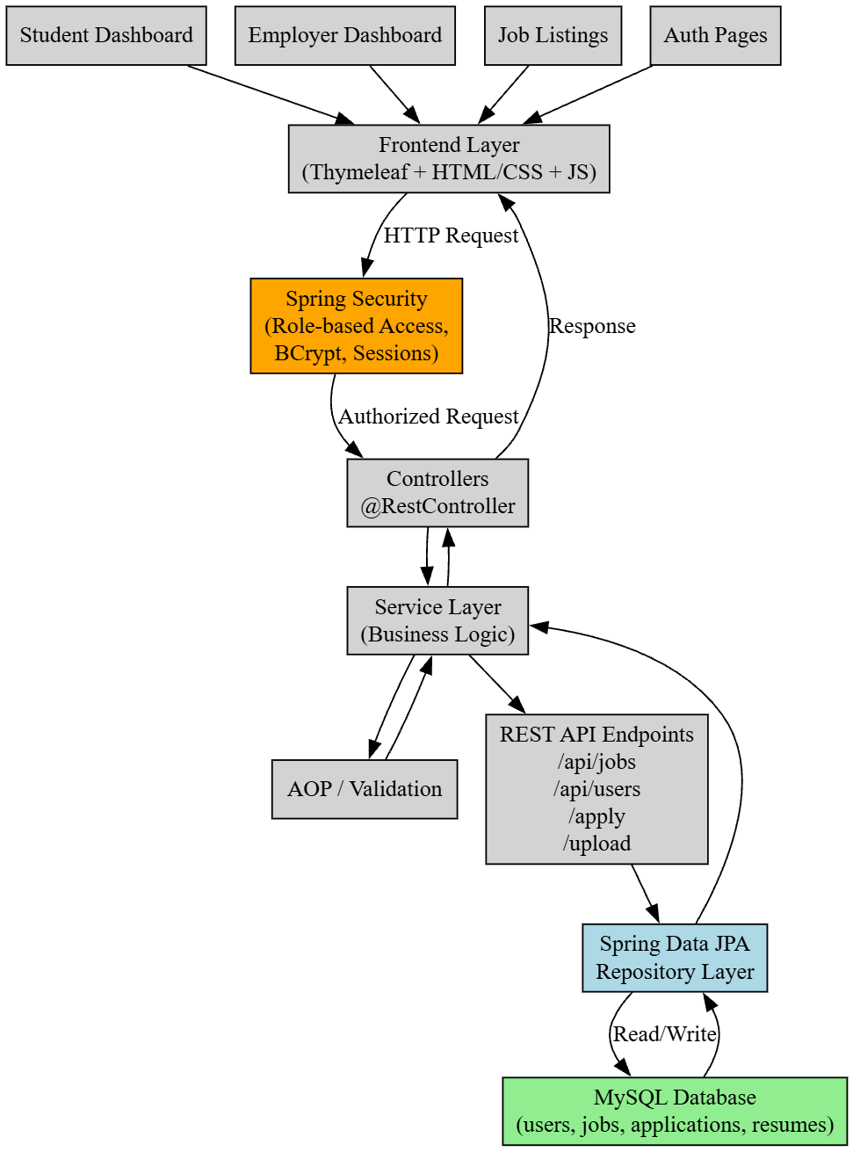

Figure 3.1: Data Flow Diagram of JobSpark Application

Database Implementation

    - Database Configuration

The database is configured using MySQL to store and manage user, job, and application data. A database named jobportaldb is auto-created using the createDatabaseIfNotExist=true parameter in application.properties.
spring.datasource.url=jdbc:mysql://localhost:3306/
1

2
jobportal_db?createDatabaseIfNotExist=true &useSSL=false&serverTimezone=UTC &allowPublicKeyRetrieval=true
spring.datasource.username=root spring.datasource.driver-class-name=
com.mysql.cj.jdbc.Driver spring.jpa.hibernate.ddl-auto=update spring.jpa.show-sql=true spring.mail.host=smtp.gmail.com spring.mail.port=587

3

4

5

6

7

8

9

10

11

Listing 3.1: application.properties — Database Configuration

    - Schema Structure

The database schema consists of four tables. The central entity is users which stores all registered users of every role. The jobs table references users through a foreign key employerid. The applications table holds jobid and applicantid as foreign keys. The savedjobs table holds studentid and job id for the bookmark feature. All relationships are managed using @OneToMany, @ManyToOne, and @JoinColumn JPA annotations.

    - Tables Created

Table 3.1: Database Tables and Key Columns
Table | Key Columns
users | id, full name, email, password, role, skills, com-pany name, resume path, created at
jobs | id, title, description, category, job type, salary, location, experience, status, expiry date, employer id
applications | id, cover letter, status, applied at, job id, applicant id
saved jobs | id, saved at, student id, job id

Chapter 4 METHODOLOGIES

Project Architecture

The project follows a three-tier layered architecture consisting of presenta-tion, application, and database layers. The Presentation Layer includes the frontend built with HTML5, CSS3, Thymeleaf, and JavaScript ES6. The Ap-plication Layer consists of the Spring Boot backend handling HTTP requests, Spring Security enforcing role-based access, service classes managing business logic, and Spring Mail handling asynchronous email dispatch. The Database Layer uses MySQL with Hibernate ORM to store all users, jobs, applications, and saved jobs.
The frontend communicates with the backend through Thymeleaf form sub-missions and Spring MVC controller mappings. Spring Security intercepts ev-ery request to validate authentication and role authorisation before routing to the appropriate controller. After successful login, CustomAuthSuccessHandler redirects students to /student/dashboard, employers to /employer, and admins to /admin/dashboard.

DataFlow Diagram

The data flow begins when the user accesses the web application and views the homepage with latest job listings. The frontend sends a request to to

fetch job information from the database. When a student fills the applica-tion form with a cover letter and submits it, the data is validated and sent to ApplicationService.apply(). The service checks for duplicate appli-cations, creates a new Application entity with PENDING status, and per-sists it to the applications table. When an employer changes the status to SHORTLISTED or REJECTED, ApplicationService.updateStatus persists the change and triggers EmailService using @Async to send an HTML email via Gmail SMTP in a background thread.

Module 1: User Interface Module

This module handles the design and interaction of the entire application. It includes the homepage with particle animation hero section, job browse page with search and filter, student dashboard with Chart.js doughnut and bar charts, employer dashboard with job management, and admin dashboard with complete platform overview. It ensures a user-friendly glassmorphism experience using CSS3 variables, JavaScript ES6 for 3D tilt effects, counter animations, confetti for shortlisted students, and toast notifications replacing plain HTML alerts.

Module 2: API and Backend Module

This module manages communication between the frontend and the database. It includes Spring MVC controller endpoints such as GET /jobs/browse for fetching job listings, POST /student/apply/{id} for processing ap-plications, POST /employer/post-job for creating job postings, and POST
/employer/application/{id}/status for updating application sta-tus. The backend validates all input data using @Valid, @NotBlank, and @Email annotations, and handles business logic through dedicated service classes.

Module 3: Database Module

This module is responsible for all data storage and management through the MySQL database with four tables: users, jobs, applications, and savedjobs. Data integrity is ensured through JPA entity relationships, effi-cient storage through Hibernate ORM, and quick retrieval through Spring Data JPA custom JPQL queries and finder methods. All tables are automatically created and updated through ddl-auto=update with no manual SQL DDL scripts required.

Advantages of this Project

    - Real-Time Application Tracking: Students instantly see whether their application is Pending, Shortlisted, or Rejected on their dashboard with colour-coded badges — no manual follow-up or external communication needed.
    - Automated Email Notifications: The system automatically sends beauti-fully formatted HTML emails when an employer changes an application status, using asynchronous Spring Mail with Gmail SMTP so it never slows the user interface.
    - Role-Based Security: Spring Security enforces strict URL-level access control ensuring students cannot access employer pages and vice versa, with BCrypt encryption protecting all passwords at rest in the database.

Disadvantages of this Project

The project currently depends on a local server setup which limits public accessibility. Advanced features such as AI-based recommendations, cloud re-sume storage, and mobile application support are not yet implemented. The system is designed for local deployment and may require optimisation for larger cloud-scale deployments.

Chapter 5

RESULTS AND DISCUSSIONS

The developed Job Portal Management System was successfully implemented and tested across all three user roles. The application allows students to view job listings, apply for jobs, and track application status efficiently. The frontend provides a glassmorphism user-friendly interface, while the Spring Boot back-end processes all requests and stores data persistently in the MySQL database. The system was verified with multiple users and all data was correctly stored and retrieved. The application ensures proper validation and displays confirma-tion messages, toast notifications, and email alerts upon successful operations.

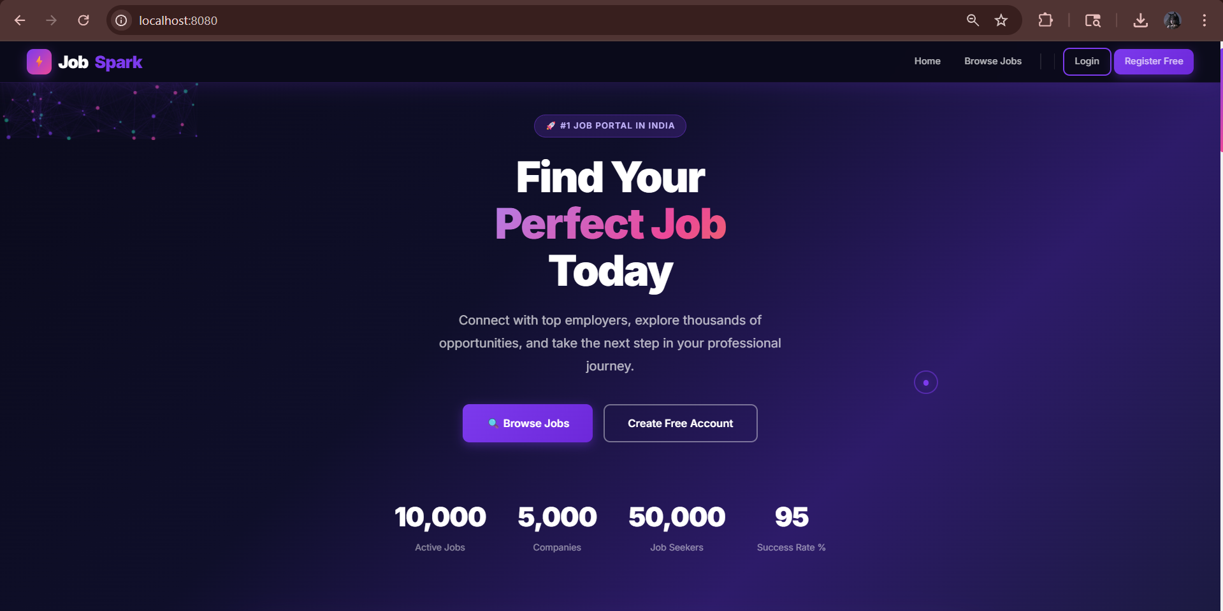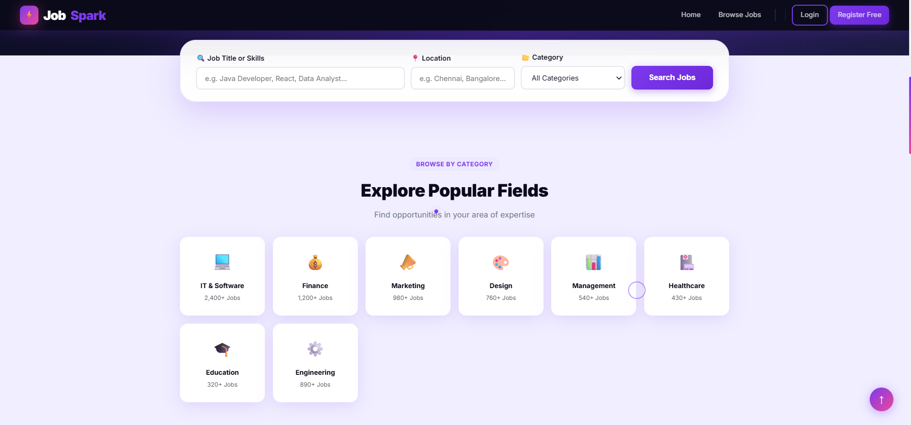
Figure 5.1: JobSpark Homepage with Particle Animation Hero Section

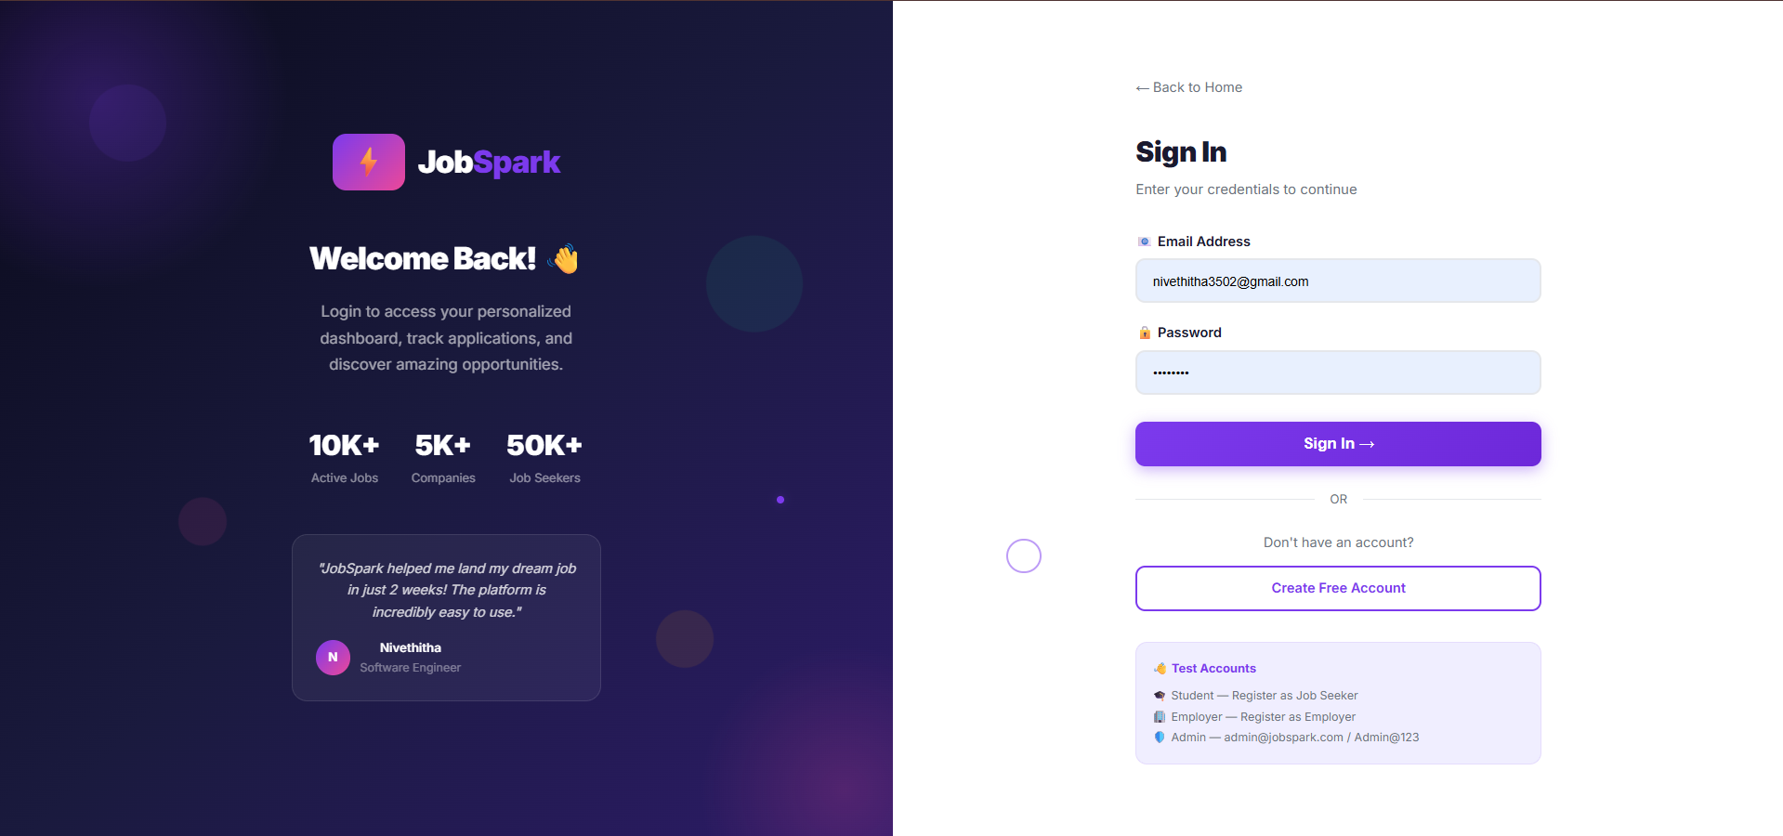
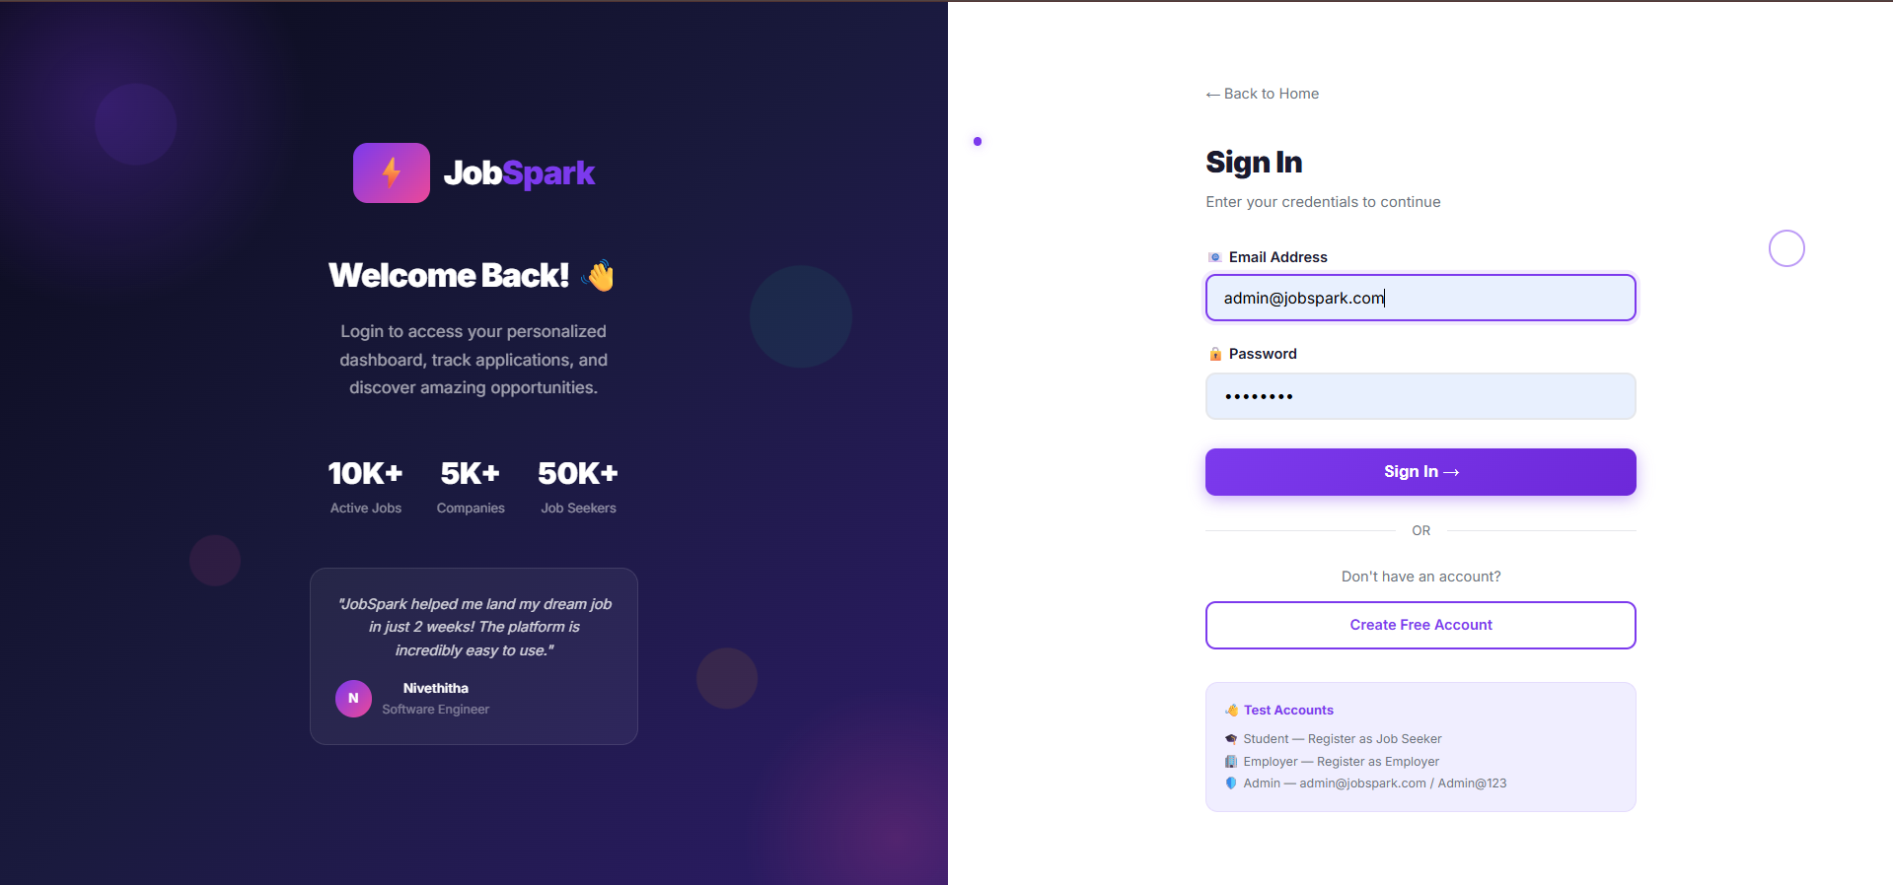

Figure 5.2: Login Page with Split-Screen Glassmorphism Design

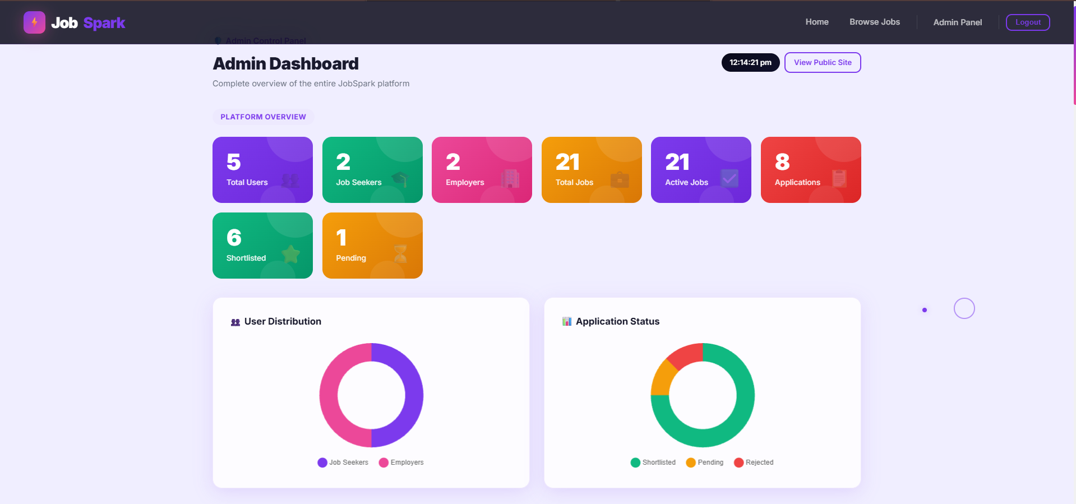

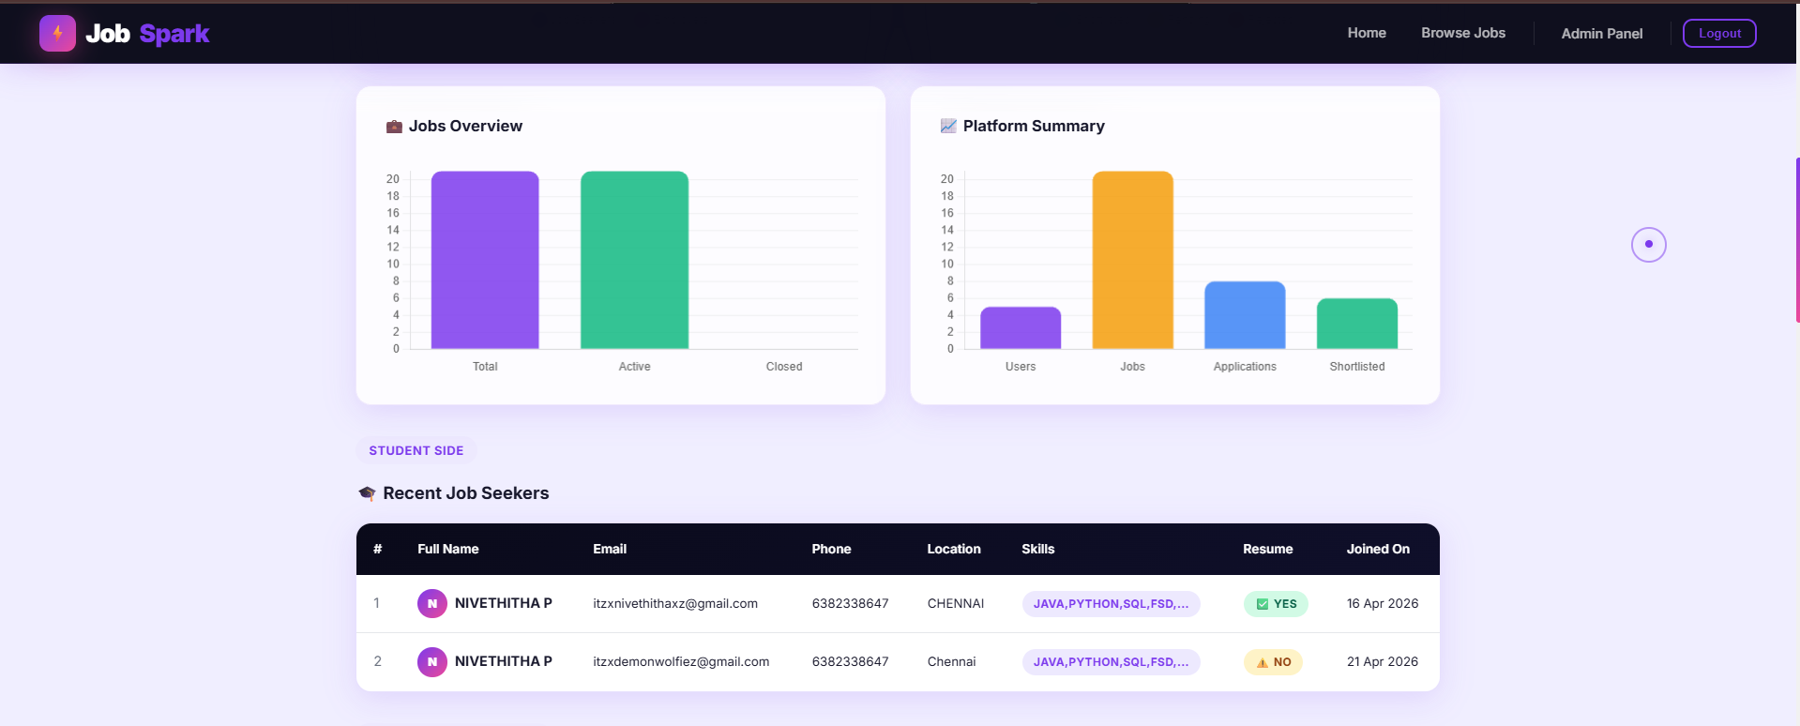

Figure 5.3: Admin Dashboard with Platform Overview and Chart.js Analytics

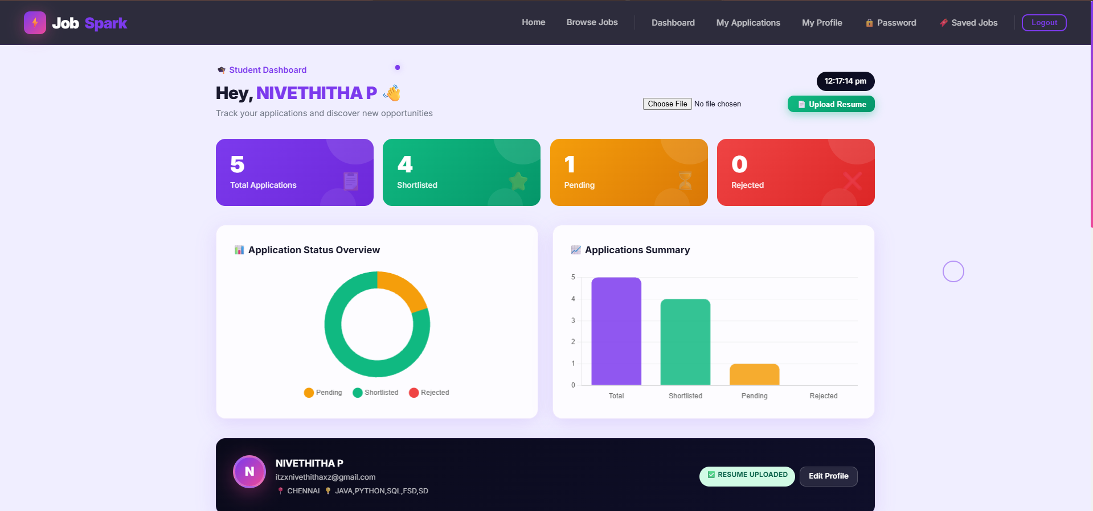

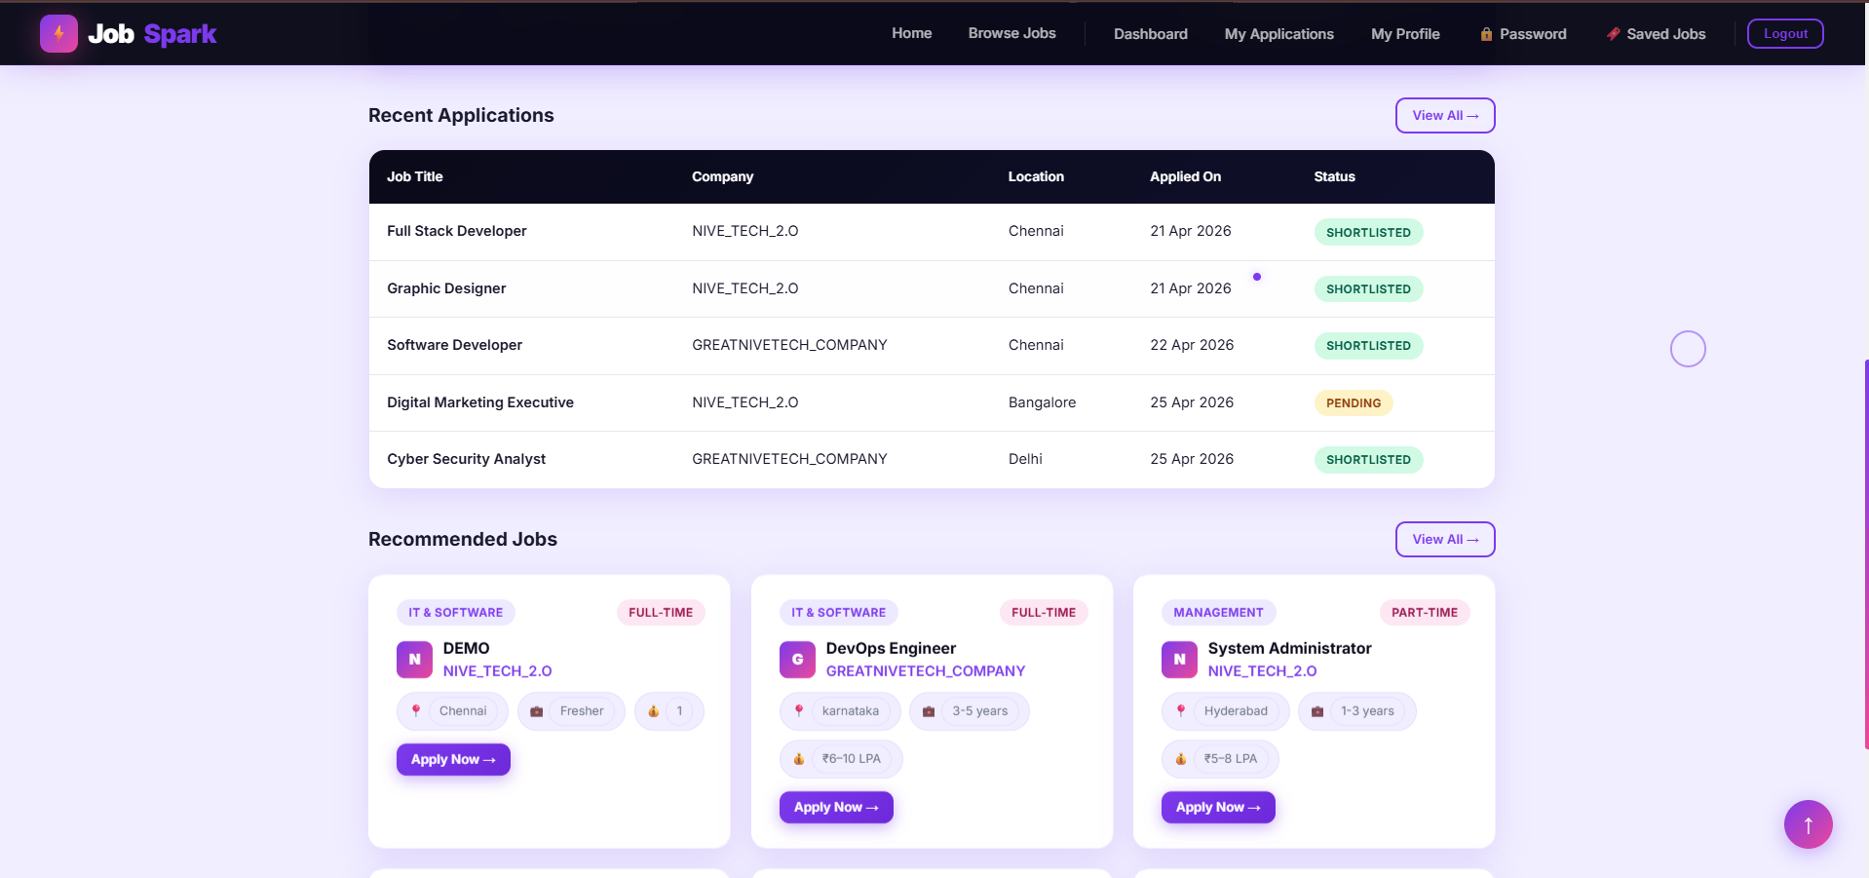

Figure 5.4: Student Dashboard with Application Statistics and Charts

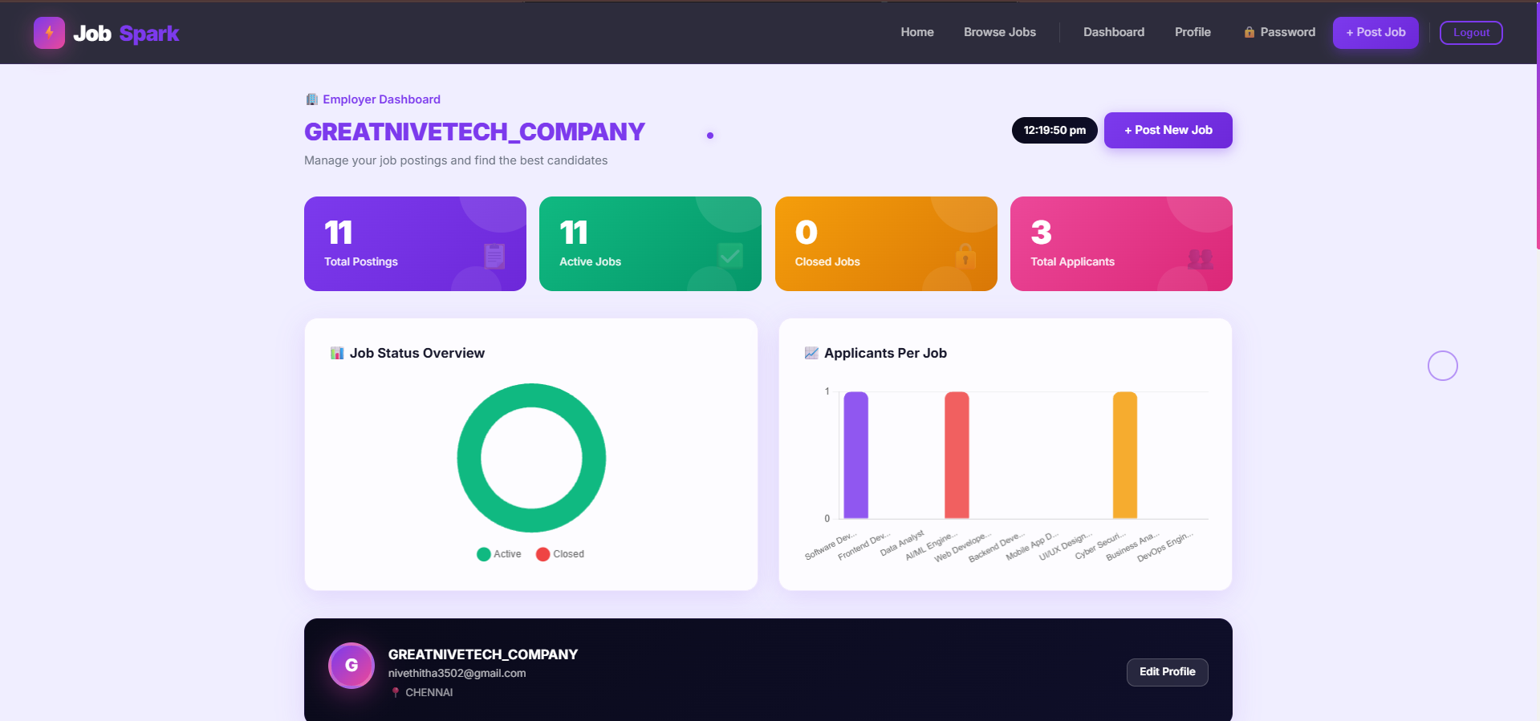

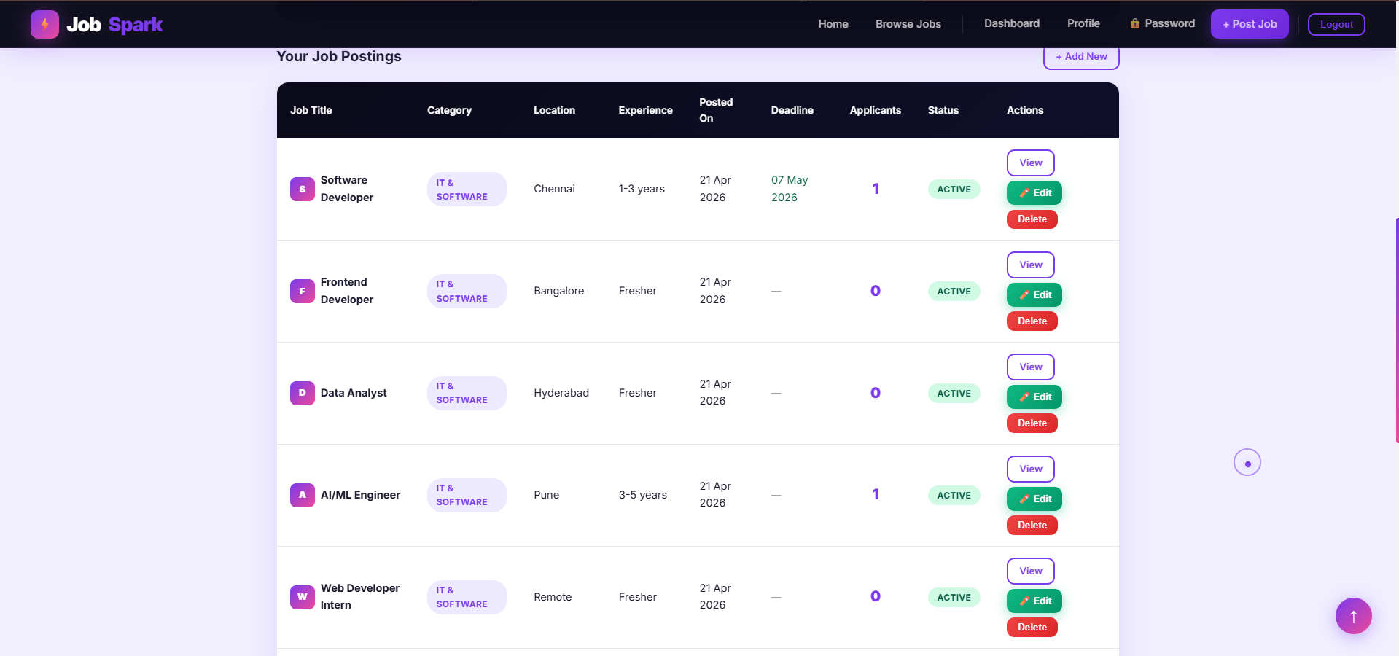

Figure 5.5: Employer Dashboard with Job Management Table and Analytics

Table 5.1: System Performance and Feature Analysis
Module | Feature | Observation / Result
Frontend | User Interface | Responsive glassmorphism de-sign with smooth animations and particle background
Frontend | Form Validation | Prevents invalid inputs using @NotBlank and @Email anno-tations
Backend | Application Process | Successfully processes and stores all applications in MySQL
Backend | Email Notification | HTML email sent on Short-list/Reject via Gmail SMTP asynchronously
Database | Data Storage | Efficient storage using four MySQL JPA tables with auto-created schema
System | Role-Based Access | Spring Security enforces URL-level role protection for all three roles
System | Performance | Fast response for all CRUD, search, and filter operations

Chapter 6 CONCLUSION AND FUTURE

ENHANCEMENTS

Conclusion

The Job Portal Management System — JobSpark — was successfully de-signed and developed using HTML5, CSS3, JavaScript ES6, Thymeleaf, Spring Boot, Spring Security, Spring Data JPA, Hibernate, and MySQL. The system provides an efficient platform for students to discover and apply for jobs, and for employers to post listings and manage applicants, through a simple and in-teractive glassmorphism interface.
The application ensures proper role-based access control, BCrypt password encryption, real-time application status tracking, automated email notifications via Gmail SMTP, and Chart.js analytics dashboards for all user roles. The in-tegration between the Thymeleaf frontend and the Spring Boot backend en-ables smooth communication and real-time data updates. Overall, the project achieves its objective of digitising the job portal process and reducing manual effort for both students and employers.

Future Enhancements

The current system can be further improved by adding advanced features and scalability options. Some possible enhancements include:

    - Implementing REST API with JWT authentication for mobile application integration
    - Integrating AI-based job recommendation algorithms using student skill profiles
    - Adding cloud deployment on AWS or Railway for public internet accessi-bility
    - Developing a dedicated Android and iOS mobile application consuming the REST API
    - Migrating resume file storage to AWS S3 or Google Cloud Storage for scalability
    - Implementing Spring Data Pageable for job listing pagination at scale

    - Adding WebSocket-based real-time chat between employers and short-listed candidates

Chapter 7 SOURCE CODE

7.1 Source Code

1
package com.jobportal.model; import jakarta.persistence.*; import lombok.*;
import java.time.LocalDateTime;
import java.util.List;

@Entity
@Table(name = "users") @Data @NoArgsConstructor @AllArgsConstructor @Builder public class User {
@Id @GeneratedValue(strategy=GenerationType.IDENTITY) private Long id;
private String fullName; private String email; private String password; @Enumerated(EnumType.STRING) private Role role;
private String phone; private String location; private String skills; private String companyName; private String resumePath; @Column(updatable = false)
private LocalDateTime createdAt; @PrePersist
protected void onCreate() { createdAt = LocalDateTime.now();
}

2

3

4

5

6

7

8

9

10

11

12

13

14

15

16

17

18

19

20

21

22

23

24

25

26

27

28

29

30

31
@OneToMany(mappedBy = "employer", cascade = CascadeType.ALL, fetch = FetchType.LAZY)
private List<Job> postedJobs; @OneToMany(mappedBy = "applicant",
cascade = CascadeType.ALL, fetch = FetchType.LAZY)
private List<Application> applications;
}

32

33

34

35

36

37

38

39

Listing 7.1: User.java — JPA Entity Class

1
package com.jobportal.security; import com.jobportal.service
.CustomUserDetailsService;
import lombok.RequiredArgsConstructor;
import org.springframework.context.annotation.*; import org.springframework.security.config
.annotation.web.builders.HttpSecurity; import org.springframework.security.config
.annotation.web.configuration
.EnableWebSecurity;
import org.springframework.security.crypto.bcrypt
.BCryptPasswordEncoder;
import org.springframework.security.crypto
.password.PasswordEncoder;
import org.springframework.security.web
.SecurityFilterChain;

@Configuration @EnableWebSecurity @RequiredArgsConstructor public class SecurityConfig {
private final CustomUserDetailsService userDetailsService;

@Bean
public PasswordEncoder passwordEncoder() { return new BCryptPasswordEncoder();
}

@Bean
public SecurityFilterChain filterChain( HttpSecurity http) throws Exception {
http
.csrf(csrf -> csrf.disable())
.authorizeHttpRequests(auth -> auth
.requestMatchers("/", "/register",

2

3

4

5

6

7

8

9

10

11

12

13

14

15

16

17

18

19

20

21

22

23

24

25

26

27

28

29

30

31

32

33

34

35

36

37
"/login", "/css/**", "/js/**", "/jobs/browse").permitAll()
.requestMatchers("/student/**")
.hasRole("STUDENT")
.requestMatchers("/employer/**")
.hasRole("EMPLOYER")
.requestMatchers("/admin/**")
.hasRole("ADMIN")
.anyRequest().authenticated()
)
.formLogin(form -> form
.loginPage("/login")
.successHandler( customAuthSuccessHandler())
.failureUrl("/login?error=true")
.permitAll()
)
.logout(logout -> logout
.logoutUrl("/logout")
.logoutSuccessUrl("/login?logout=true")
.permitAll()
)
.userDetailsService(userDetailsService); return http.build();
}

@Bean
public CustomAuthSuccessHandler customAuthSuccessHandler() {
return new CustomAuthSuccessHandler();
}
}

38

39

40

41

42

43

44

45

46

47

48

49

50

51

52

53

54

55

56

57

58

59

60

61

62

63

64

65

66

67

68

Listing 7.2: SecurityConfig.java — Spring Security Configuration

1
package com.jobportal.service; import com.jobportal.model.*; import com.jobportal.repository
.ApplicationRepository;
import lombok.RequiredArgsConstructor;
import org.springframework.stereotype.Service; import java.util.*;

@Service @RequiredArgsConstructor
public class ApplicationService { private final ApplicationRepository
applicationRepository;

2

3

4

5

6

7

8

9

10

11

12

13

14

15

16

17

18

19

20

21

22

23

24

25

26

27

28

29

30

31

32

33

34

35

36

37

38

39

40

41

42

43

44

45

46

47

48

49

50

51

52

53

54

55
56 }
private final EmailService emailService;

public Application apply(Job job,
User applicant, String coverLetter) { if (applicationRepository
.existsByJobAndApplicant(job, applicant)) throw new RuntimeException(
"Already applied for this job!"); Application app = Application.builder()
.job(job).applicant(applicant)
.coverLetter(coverLetter).build(); return applicationRepository.save(app);
}

public Application updateStatus( Long applicationId, ApplicationStatus status) {
Application app = applicationRepository
.findById(applicationId)
.orElseThrow(() ->
new RuntimeException( "Application not found"));
app.setStatus(status); Application saved =
applicationRepository.save(app);
if (status == ApplicationStatus.SHORTLISTED
|| status == ApplicationStatus.REJECTED) {
emailService.sendApplicationStatusEmail( app.getApplicant().getEmail(), app.getApplicant().getFullName(), app.getJob().getTitle(), app.getJob().getEmployer()
.getCompanyName(), status.name());
}
return saved;
}

public List<Application> getAllApplications(){ return applicationRepository.findAll();
}

Listing 7.3: ApplicationService.java — Email Notification on Status Update

1
package com.jobportal.service; import com.jobportal.model.*;

2

3
import com.jobportal.repository
.SavedJobRepository;
import lombok.RequiredArgsConstructor;
import org.springframework.stereotype.Service; import org.springframework.transaction
.annotation.Transactional; import java.util.List;

@Service @RequiredArgsConstructor public class SavedJobService {
private final SavedJobRepository savedJobRepository;

@Transactional
public boolean toggleSaveJob( User student, Job job) {
if (savedJobRepository
.existsByStudentAndJob(student, job)) { savedJobRepository
.deleteByStudentAndJob(student, job); return false;
} else {
SavedJob savedJob = SavedJob.builder()
.student(student).job(job).build(); savedJobRepository.save(savedJob); return true;
}
}

public List<SavedJob> getSavedJobs( User student) {
return savedJobRepository
.findByStudent(student);
}

public boolean isJobSaved( User student, Job job) {
return savedJobRepository
.existsByStudentAndJob(student, job);
}
}

4

5

6

7

8

9

10

11

12

13

14

15

16

17

18

19

20

21

22

23

24

25

26

27

28

29

30

31

32

33

34

35

36

37

38

39

40

41

42

43

44

Listing 7.4: SavedJobService.java — Job Bookmark Toggle Feature

Chapter 8 ADDRESSING COMPLEX

ENGINEERING PROBLEM AND SDG

Mapping of the Project to Complex Engineering Problem (CEP)
The JobSpark Job Portal Management System addresses several attributes of Complex Engineering Problems as defined by engineering education stan-dards. The following table maps each attribute to specific characteristics and knowledge areas demonstrated by this project.

Table 8.1: Mapping of Project to Complex Engineering Problem (CEP)
Level | Attribute | Characteristic | sWKs | Justification
WP1 | Depth of Knowl-edge | Requires in-depth  engineering knowledge | WK3, WK4, WK5, WK6 | Requires knowledge in Spring Boot, Spring Security, JPA/Hiber-nate, MySQL, and Gmail SMTP for building a secure multi-role web system.
WP2 | Conflicting Require-ments | Technical and non-technical conflicts | WK4, WK5, WK6 | Balances security and usability — BCrypt hashing must not slow UX, and role-based restrictions must not hinder legitimate access.
WP3 | Depth of Analysis | Analytical and design thinking | WK3, WK4, WK5 | Involves MVC architecture de-sign, JPA entity relationship mod-elling, and async email service in-tegration with real-time applica-tion tracking.
WP4 | Familiarity | Partially new problems | WK4, WK8 | Glassmorphism UI with Chart.js analytics and async email notifi-cations introduces challenges be-yond traditional web systems.
WP5 | Applicable Codes | Limited standard solutions | WK6 | Requires custom JPQL search queries, custom Spring Security handlers, and a custom HTML email template builder.
WP6 | Stakeholder Needs | Multiple stakeholders involved | WK5, WK6, WK7 | Handles requirements of stu-dents (job seekers), employers (recruiters), and administrators en-suring secure and role-appropriate interactions.
WP7 | Interdepende | nScyestem-level integration | WK3, WK5, WK6 | Integrates Thymeleaf views, Spring MVC controllers, service logic, JPA repositories, MySQL, and Gmail SMTP into one cohe-sive system.

Mapping of the Project to Complex Engineering Activi-ties (CEA)

Table 8.2: Mapping of Project to Complex Engineering Activities (CEA)
EA  No. | Attribute | Characteristics | Justification
EA1 | Range of Resources | Use of diverse technologies | Spring Boot, Spring Security, JPA, Hi-bernate, Thymeleaf, MySQL, Chart.js, Gmail SMTP, JavaScript ES6, CSS3 Glassmorphism.
EA2 | Level of Interac-tions | Complex module inter-actions | Student application module, employer job management, admin oversight, email ser-vice, and Spring Security all interact si-multaneously.
EA3 | Innovation | Modern tech-nologies | Chart.js dashboards, canvas particle an-imations, 3D card tilt effects, glassmor-phism UI, confetti animations, and async email dispatch demonstrate innovation.
EA4 | Societal Impact | Impact on  users and society | Improves employment accessibility for students, reduces manual recruitment overhead for employers, and promotes digital transformation of hiring.
EA5 | Familiarity | Beyond stan-dard practices | Combines role-based security, async email processing, real-time animations, job expiry, cover letter modals, and book-marks beyond typical CRUD apps.

SDG Mapping

Table 8.3: SDG Mapping for the Project
SDG  No. | SDG Title | Relevance to the Project
SDG 4 | Quality Education | Provides a platform for students and fresh grad-uates to discover jobs, supporting career readi-ness through accessible digital tools at no cost.
SDG 8 | Decent Work and Economic Growth | Directly connects job seekers with employers, reducing unemployment gaps and enabling effi-cient talent discovery which contributes to eco-nomic growth.
SDG 9 | Industry, Innovation and Infrastructure | Promotes digital transformation in recruitment using Spring Boot, Chart.js analytics, and auto-mated email — demonstrating modern software innovation.
SDG 10 | Reduced Inequali-ties | Provides a completely free platform with no premium paywalls, ensuring equal access to job opportunities for students from all economic backgrounds.
SDG 16 | Peace, Justice and Strong Institutions | Ensures secure data management through BCrypt hashing, CSRF protection, and role-based access control protecting all stakeholders.

References

- VMware Inc. (2024). Spring Boot Documentation. Spring Boot Official Reference, 1(1), pp. 1–20.
https://docs.spring.io/spring-boot/docs/ current/reference/html/
- VMware Inc. (2024). Spring Security Reference Documentation. Spring Security Official Docs, 2(1), pp. 1–18. https://docs.spring.io/spring-security/ reference/index.html
- VMware Inc. (2024). Spring Data JPA Documentation. Spring Data Official Reference, 3(2), pp. 1–15. https://docs.spring.io/spring-data/jpa/ docs/current/reference/html/
- The Thymeleaf Team (2024). Thymeleaf Documentation. Thymeleaf Offi-cial Docs, 4(1), pp. 1–12. https://www.thymeleaf.org/documentation.html
- Oracle Corporation (2024). MySQL 8.0 Reference Manual. MySQL Offi-cial Documentation, 5(3), pp. 1–20. https://dev.mysql.com/doc/refman/8.0/en/
- Chart.js Contributors (2024). Chart.js Documentation. Chart.js Official Docs, 6(1), pp. 1–10.
https://www.chartjs.org/docs/latest/
- The Lombok Authors (2024). Project Lombok Documentation. Lombok Official Docs, 7(1), pp. 1–8.

https://projectlombok.org/features/
- The Apache Software Foundation (2024). Apache Maven Documentation. Maven Official Guides, 8(2), pp. 1–10. https://maven.apache.org/guides/
- Info Edge India Ltd. (2024). Naukri.com — India’s No.1 Job Portal.
Naukri Technical Report, 9(1), pp. 1–5.
https://www.naukri.com
- LinkedIn Corporation (2024). LinkedIn Jobs Platform. LinkedIn Engineer-ing Journal, 10(2), pp. 1–8.
https://www.linkedin.com/jobs/
- Indeed Inc. (2024). Indeed Job Search Platform. Indeed Technical Docu-mentation, 11(1), pp. 1–6.
https://www.indeed.com
- Internshala (2024). Internshala — Internships and Jobs for Students. In-ternshala Platform Guide, 12(1), pp. 1–5. https://www.internshala.com.

